1) under calc.js write 2 functions -1 to calculate product of 2 sumbers 2 - sum of 2 numbers

Export both the functions.

Import and call these functions from another module.

Calculator.js

function product(n1, n2) {

  return n1 \* n2;

}

function sum(n1, n2) {

  return n1 + n2;

}

export { product, sum };

main.js

import { product, sum } from "./calculator.js";

function main() {

  console.log("Product is : " + product(2, 4));

  console.log("Sum is : " + sum(7, 6));

}

main();

package.json

{

  "name": "day9",

  "version": "1.0.0",

  "description": "",

  "main": "index.js",

  "type": "module",

  "scripts": {

    "test": "echo \"Error: no test specified\" && exit 1"

  },

  "author": "",

  "license": "ISC",

  "module": "esnext"

}

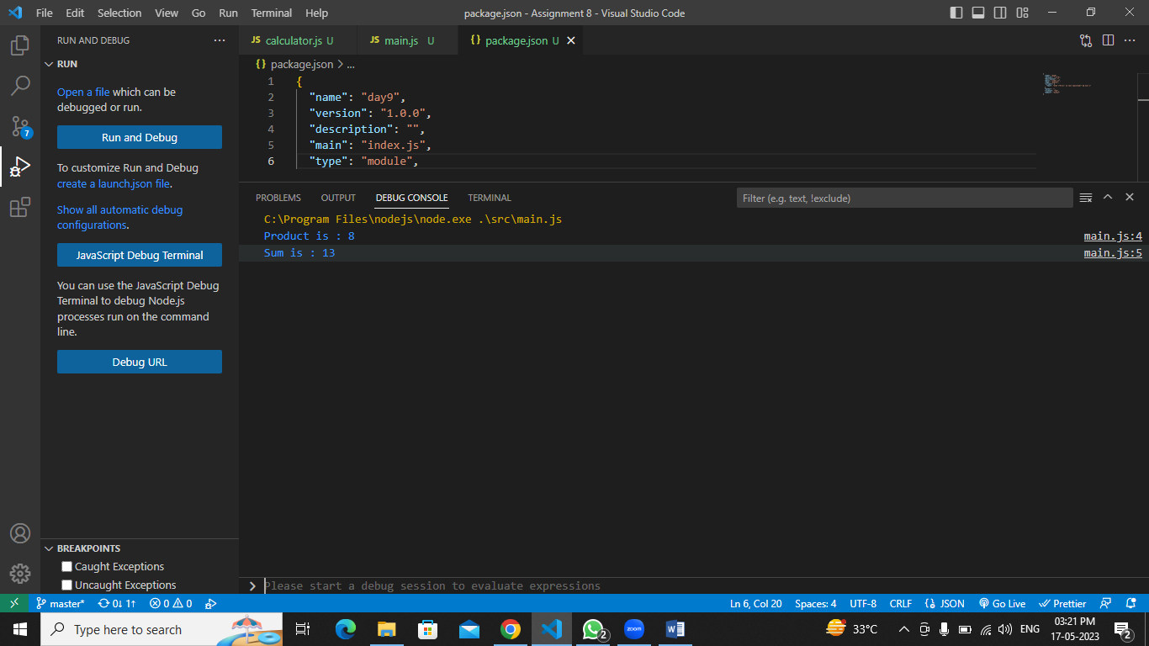

2) Create a js function to write a string to a file Create another js function to read and return the contents of a file. Call these 2 functions from another module.

Write.js

import { writeFileSync } from "node:fs";

import { readFileSync } from "node:fs";

function write() {

  let data = "hello World ";

  let filePath = "C:/Users/Paresh/Desktop/Web Programing/Assignment 8/abc.txt";

  writeFileSync(filePath, data);

  console.log("File written successfully");

  console.log("File has following content");

  let fileData = readFileSync(filePath, { encoding: "utf-8" });

  console.log(fileData);

}

export { write };

read.js

import { readFileSync } from "node:fs";

function read() {

  let filePath = "C:/Users/Paresh/Desktop/Web Programing/Assignment 8/demo.txt";

  let fileData = readFileSync(filePath, { encoding: "utf-8" });

  console.log(fileData);

}

export { read };

FileMain.js

import { write } from "./write.js";

import { read } from "./read.js";

function main() {

  write();

  read();

}

main();

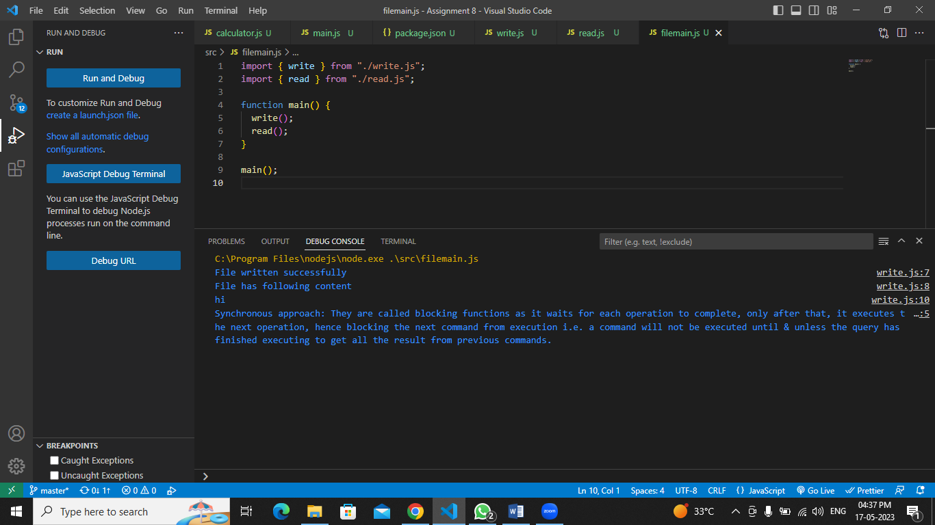

3) practice installing & un installing an external module eg:- bootstrap to your Node.js project.

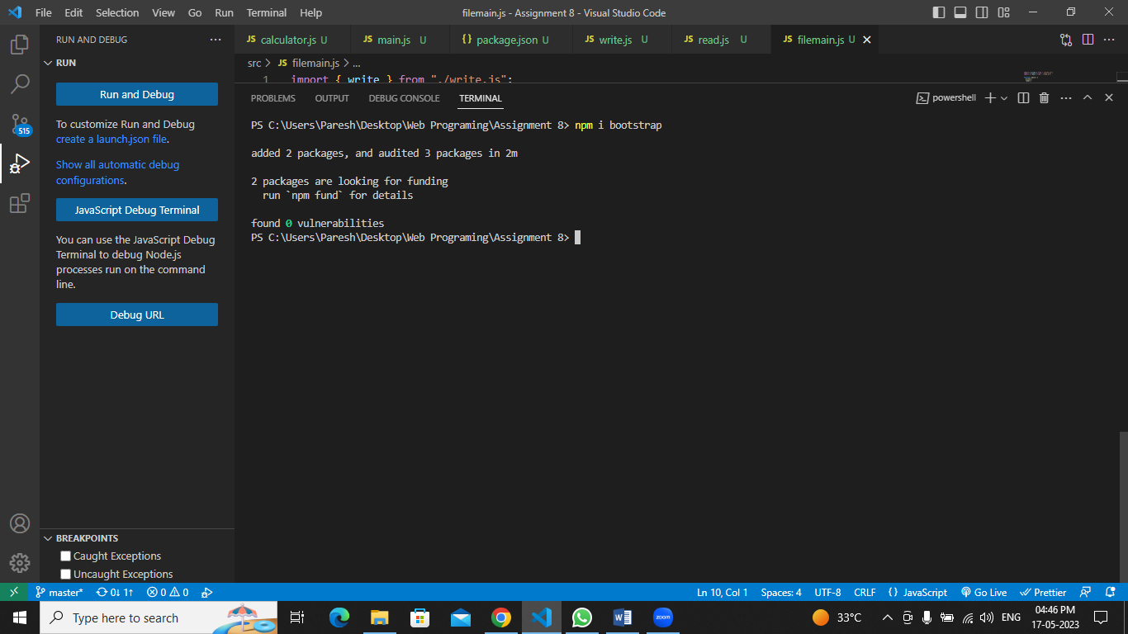

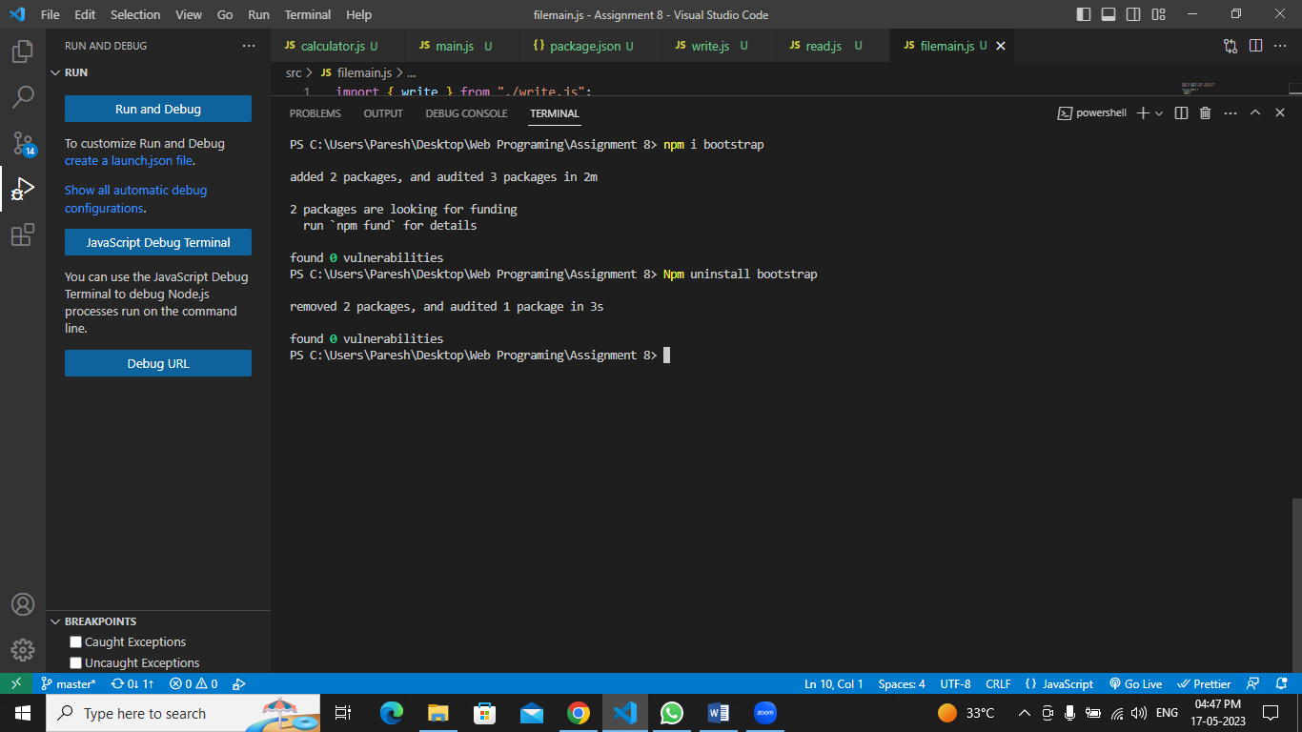

4) using AJAX make a call to the url

https://jsonplaceholder.typicode.com/todos/

&

https://jsonplaceholder.typicode.com/todos/<id>

and display the results.

AjaxCall.js

async function apicall() {

  let path = "https://jsonplaceholder.typicode.com/todos";

  let result = await fetch(path);

  let data = await result.json();

  console.log(data);

  for (let item of data) {

    let displaytag = document.querySelector("#display");

    let existingvalue = displaytag.innerHTML;

    let newdata = `<h1>Userid: ${item.id}</h1> <h2>${item.title}</h2><p style="font-size:21px">${item.completed}</p>`;

    displaytag.innerHTML = existingvalue + newdata;

  }

}

Home.html

<!DOCTYPE html>

<html lang="en">

  <head>

    <meta charset="UTF-8" />

    <meta http-equiv="X-UA-Compatible" content="IE=edge" />

    <meta name="viewport" content="width=device-width, initial-scale=1.0" />

    <title>Ajax API Call</title>

    <script src="./ajaxCall.js"></script>

  </head>

  <body>

    <input type="button" value="Click to Call API" onclick="apicall()" />

    <div id="display"></div>

  </body>

</html>

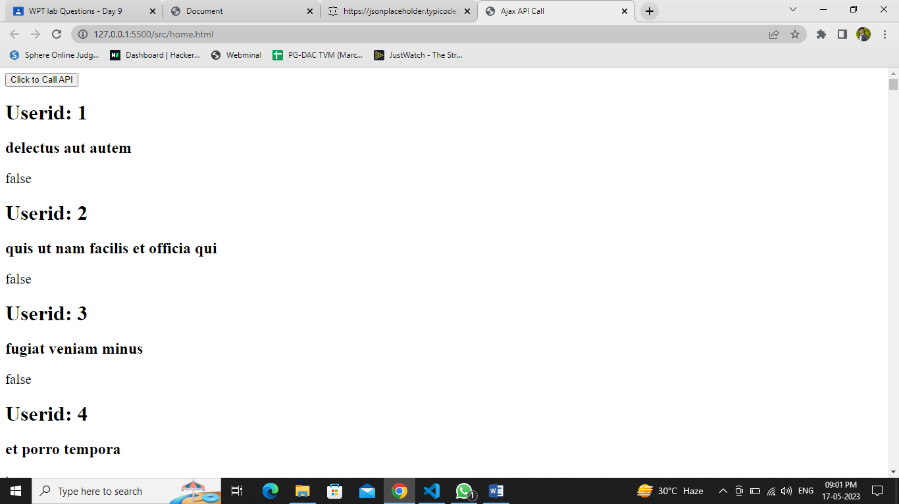

AjaxCall using id.js

async function apicallUsingID() {

  let idtag = document.querySelector("#id");

  let loc = idtag.value;

  let path = `https://jsonplaceholder.typicode.com/todos/${loc}`;

  let result = await fetch(path);

  let data = await result.json();

  console.log(data);

  let displaytag = document.querySelector("#display");

  let newdata = `<h1>Userid: ${data.id}</h1> <h2>${data.title}</h2><p style="font-size:21px">${data.completed}</p>`;

  displaytag.innerHTML = newdata;

}

Index.html

<!DOCTYPE html>

<html lang="en">

  <head>

    <meta charset="UTF-8" />

    <meta http-equiv="X-UA-Compatible" content="IE=edge" />

    <meta name="viewport" content="width=device-width, initial-scale=1.0" />

    <script src="./apicallUsingID.js"></script>

    <title>Document</title>

  </head>

  <body>

    <input type="text" placeholder="Enter ID" id="id" />

    <input type="button" value="Press to call API" onclick="apicallUsingID()" />

    <div id="display"></div>

  </body>

</html>

